DEVS Grocery Store

Student Names:
Joseph Andrews
Grant Phillips
Date: February 25, 2026
Course: SYSC4906G

Table of Contents
Table of Contents 2
Project Overview and Objectives 4
Overview 4
Objectives 4
System Description and Assumptions 4
System Description 4
Assumptions 4
Modernization changes 5
Modification 1: Garage/Conveyor System -> Curbside Pickup System 5
Modification 2: Express Register -> Self-Checkout Zone 5
Modification 3: Generator extended for Online Orders 5
Modification 4: New PaymentProcessor Atomic Model 6
Model architecture and hierarchy 6
Ports, messages, and coupling scheme 7
Ports 7
Generator 7
Distributor 7
Cash 8
Payment Processor 8
Traveler 8
Packer 8
CurbsideDispatcher 9
CustomerSink 9
Messages 9
Coupling Scheme: 10
Atomic models 10
Experimentation and test framework 18
Generator 18
Distributor 20
Cash 22
CurbsideDispatcher 23
Packer 24
Payment 25
Traveler 26
Pickup System Coupled 27
One Customer Integration 28
Full System Tests 29
Simulation experiments and test frameworks 33
Implementation notes and how to run 38
Repository Structure: 38
Requirements 39
Building and Running 39
Build the main simulation: 39
Run the main simulation: 39
Build the unit/integration tests: 39
Run the tests: 39
Input Files 39
Simulation Logs 39

Project Overview and Objectives

Overview
This project involves adapting and modernizing a discrete-event simulation of a grocery store checkout system. The original model was created in 2002 using the CD++ simulation tool. For this assignment, we are migrating the system to the Cadmium DEVS simulator. In the process, the underlying system logic has been updated to reflect modern retail operations by replacing outdated concepts with current practices.

Objectives
The primary objective of this simulation is to model the flow of customers through a grocery store checkout to determine the average time a customer is expected to spend in the system. By using DEVS formalism, we aim to analyze how different conditions such as varying the ratio of online-order pickups to walk-in customers, or altering the payment processing time will affect the system throughput.

System Description and Assumptions

System Description
The modeled system represents a modern grocery store checkout system. The system generates two types of customers: traditional walk-in customers and online click-and-collect customers.
When a walk-in customer approaches the checkout area, routing logic distributes them to either a staffed register or a self-checkout kiosk based on their item count. Once their items are scanned, the customer moves to payment processing, where the time taken depends on whether they use tap/card or cash. After payment, customers may walk out of the store.

Separately, online orders bypass the traditional checkout entirely. They are routed to a curbside pickup system where staff pack groceries at a designed parking spot. The system then dispatches a notification, and the customer arrives to collect their order.

Assumptions
- Customers never leave a queue once they have entered it
- The routing distributor assigns lanes instantly
- Customers with 15 or fewer items are strictly routed to the self-checkout zone
- Time time it takes to scan items is proportional to the number of items
- The availability of curbside pickup spots is assumed to be infinite

Modernization changes
The original grocery store model was developed in 2002 as a CD++ simulation. While the core DEVS structure remains the same, the system in which it represents has changed significantly since the model was created over 2 decades ago. Modern grocery stores have introduced self-checkout kiosks, curbside pickup, contactless payment and online order fulfillment, none of which exist in the original model. To reflect these changes, we made four modifications to the original design.

Modification 1: Garage/Conveyor System -> Curbside Pickup System
The original model included a Car System composed of a Conveyor and a Searcher. After checkout, customers with cars had their groceries sent to a garage via a conveyor belt, where a searcher located the correct bag using a receipt slip. This system was replaced with a modern Curbside Pickup System consisting of two new atomic models: a Packer which models the time staff take to prepare an order and a CurbsideDispatcher which models the customer collecting their order from the assigned spot. This preserves the two-component coupled sub-system structure of the original car system while accurately representing how modern grocery fulfillment operates.

Modification 2: Express Register -> Self-Checkout Zone
The original model included a single express register that only accepted customers with fewer than 8 items. This was replaced with a self-checkout routing rule inside the Distributor which routes customers with 15 or fewer items to a self-checkout lane, while customers with more than 15 items are routed to a staffed register.

Modification 3: Generator extended for Online Orders
The original Generator produced only walk-in customers. A new boolean attribute, `isOnlineOrder` was added to each generated customer. When `isOnlineOrder` is true, the Distributor bypasses all checkout lanes and routes the customer directly to the Curbside Pickup System. This was added as click-and-collect services have become a standard part of modern grocery stores; these customers do not interact with any checkout lane but rather arrive at the store to pick up a pre-packed order.

Modification 4: New PaymentProcessor Atomic Model
In the original model, the Cash register’s service time was calculated as `NumberOfItems x TimePerItem` with no distinction made for the payment system. A new PaymentProcessor atomic model was inserted between Cash and Traveler. It models two payment types: tap/card payment, which completes quickly (5-15 seconds), and cash payment, which takes longer. We made this change as modern payment methods have an impact on checkout throughput in real grocery stores. While tap/card payment have become the dominant form of payment, cash transactions still occur and take significantly longer. By separating the forms of payment, the simulation becomes more accurate, it also becomes more modular as payment behaviour can be adjusted independently of scanning behaviour without modifying the Cash model.

Model architecture and hierarchy
The simulation is implemented as a three-level DEVS hierarchy. The top-level grocery store coupled model contains 5 atomic models and one coupled model, PickupSystem which encapsulates the two atomic models: Packer and CurbsideDispatcher responsible for online order fulfillment.
GroceryStore [Coupled]
├── Generator [Atomic]
├── Distributor [Atomic]
├── Cash [Atomic]
├── PaymentProcessor [Atomic]
├── Traveler [Atomic]
├── PickupSystem [Coupled]
│ ├── Packer [Atomic]
│ └── CurbsideDispatcher [Atomic]
└── CustomerSink [Atomic]

Generator - Produces customers arrivals
Distributor - Routes walk-in customers to available checkout lanes, online orders bypass checkout
Cash - Processes one customer at a time
PaymentProcessor: Serializes payment after scanning
Traveler: Models a walk-in customer walking to their car post payment
Packer: Online orders only
CurbsideDispatcher: Holds each packed order for travelTime seconds before releasing it as a completed pickup
CustomerSink - Absorbs completed customers

Ports, messages, and coupling scheme

Ports

Generator

Port | Direction | Type | Description
holdOff | In | bool | Received from Distributor: pauses customer generation
okGo | In | bool | Received from Distributor: resumes customer generation
customerOut | Out | CustomerData | Emits a newly generated customer on each int transition

Distributor
Port | Direction | Type | Description
inCustomer | In | customerData | Incoming customer from Generator
in_laneFreed | In | int | Lane ID signal from cash on service completion
out_cash0-2 | Out | CustomerData | Routes customers to a specific staffed lane
out_self0-1 | Out | CustomerData | Routes customers to a specific self-checkout lane
out_online | Out | CustomerData | Bypasses all checkout lanes for online orders
out_holdOff | Out | bool | Tells Generator to pause when all queues are at capacity
out_okGo | Out | bool | Tells Generator to resume when a lane frees up

Cash
Port | Direction | Type | Description
in_customer | In | CustomerData | Customer arriving to lane
out_toPayment | Out | CustomerData | Customer forwarded to PaymentProcessor
out_free | Out | int | Emits lane ID to notify Distributor of availability

Payment Processor
Port | Direction | Type | Description
custIn | In | CustomerData | Customer arriving from any cash lane
custOut | Out | CustomerData | Customer forwarded to Traveler after completion

Traveler
Port | Direction | Type | Description
custIn | In | CustomerData | Walk-in customer after payment
custArrived | Out | CustomerData | Emitted when the customer reaches their car

Packer
Port | Direction | Type | Description
in_order | In | CustomerData | Online order received directly from Distributor
out_packed | Out | CustomerData | Order forwarded to CurbsideDispatcher once packed

CurbsideDispatcher
Port | Direction | Type | Description
orderIn | In | CustomerData | Packed order from Packer
finished | Out | CustomerData | Emitted after travelTime seconds, signalling customer collected order

CustomerSink
Port | Direction | Type | Description
in | In | CustomerData | Completed customer to be absorbed.

Messages
The simulation uses three message types across all ports:
CustomerData - the primary message type, defined in atomics/customer_data.hpp. It carries all customer attributes through the model

Field | Type | Description
customerId | int | Unique identifier assigned by the Generator
numItems | int | Number of grocery items (uniform random, 1–40)
isOnlineOrder | bool | true = curbside pickup path; false = walk-in checkout path
paymentType | bool | true = card/tap; false = cash
travelTime | double | Used by Traveler (walk-in exit time) and CurbsideDispatcher (pickup wait time)
searchTime | double | Used by Packer to determine online order packing duration

bool - used only by the Generator for its feedback ports
int - used on the out_free and in_landFreed ports to communicate which lane ID is available.

Coupling Scheme:
Two distinct customer flows exist in the model: One for walk-in customers and one for online orders/pickups.

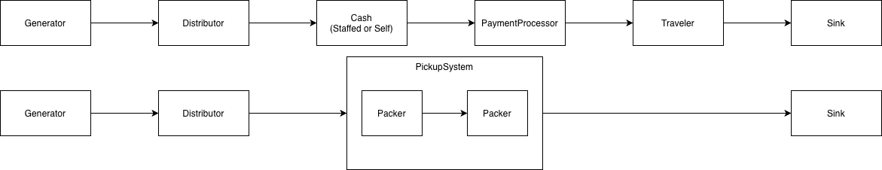

Atomic models
Generator
DEVS Model
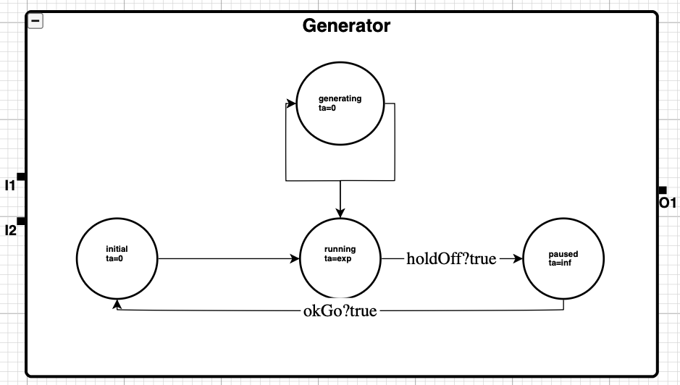
Formal Specification

$M_{dist}=(X, Y, δ_{ext} , δ_{int} ,λ, ta)$
$X = \{okGo ϵ B, holdOff ϵ B\}$
$Y = \{customerOut ϵ CustomerData\}$
$S = \{phase ϵ \{paused, running, generating\}, σ ϵ {R_{inf}}^{+}\}$
$ta(initial) =0$
$ta(paused) = ∞$
$ta(generating) = 0$ (Immediate dispatch)

Transition Functions (pseudo-code):
δext:
(okGo received, paused) → running
(holdOff received, running) → paused
δint:
running → generating
generating → running
λ (output):
sending: emit CustomerData to customerOut

PaymentProcessor
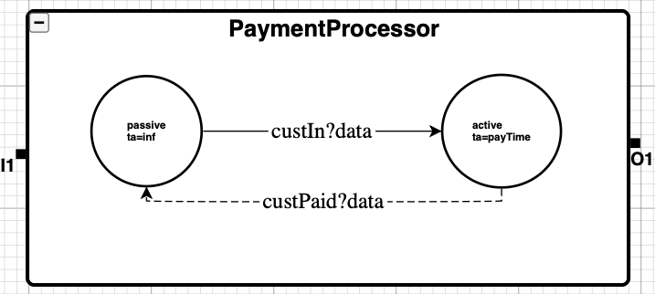

Formal Specification:
$M_{pay} = (X, Y, S, δ_{ext} , δ_{int} , λ, ta)$
$X = \{custForPayment ϵ CustomerRecord\}$
$Y = \{custPaid ϵ CustomerRecord\}$
$S = \{phase ϵ \{passive, active\}, σ ϵ {R_{inf}}^{+}, currentCustomer, queue\}$
$ta(passive) = inf$
$ta(active) = σ$ (set by payment type)

Transition Functions (Pseudocode):
δext (custForPayment received):
(custIn received, passive) → busy
(custIn received, busy) → busy
λ (output, before δint):
emit custPaid = currentCustomer // forward to Traveler or PickupSystem
δint:
busy → passive
busy → busy
get(jobQueue),$σ$ = payTime()
λ (output):
busy: emit job to custPaid

Traveler
DEVS Model
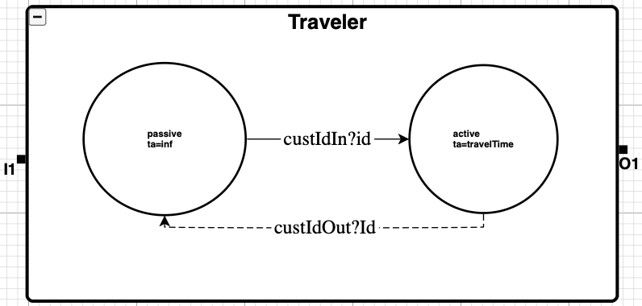

Formal Specification:
$M_{trav} = (X, Y, S, δ_{ext} , δ_{int} , λ, ta)$
$X = \{custIn ϵ CustomerData\}$
$Y = \{custArrived ϵ CustomerData\}$
$S = \{phase ϵ \{passive, active\}, σ ϵ {R_{inf}}^{+}\}$
$ta(passive) = inf$
$ta(active) = travelTime$

Transition Functions (Pseudocode)
δext:
(custIn received, passive) → busy
(custIn received, busy) → busy
δint:
busy → passive
busy → busy
get(jobQueue), $σ$ = job.travelTime

λ (output):
busy: emit job to CustArrived

Distributor
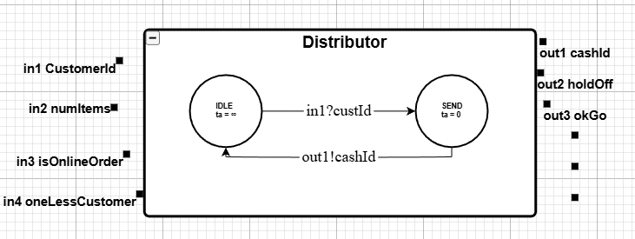
Formal Specification:
$M_{Distributor} = (X, Y, S, δ_{ext} , δ_{int} , λ, ta)$
$X = \{customerId (int), numItems (int), isOnlineOrder(0/1), oneLessCustomer(int)\}$
$Y = \{cashId(int), holdOff(bool), okGo(bool)\}$
$S = \{idle, send\}$
$ta(IDLE) = inf$
$ta(SEND) = 0$

δext
IF input = in1 (customerId arrives):
IF there exists a register with space:
selectedCashId = register with smallest queue
queues[selectedCashId]++
decision = ROUTE
ELSE
decision = HOLD
phase = SEND
IF input = in4 (cashIdFreed):
queues[cashIdFreed]--
decision = OK
phase = SEND
δint(SEND) = IDLE
λ
IF decision = ROUTE
output selectedCashId on out1
ELSE IF decision = HOLD
output true on out2
ELSE IF decision = OK
output true on out3

Packer
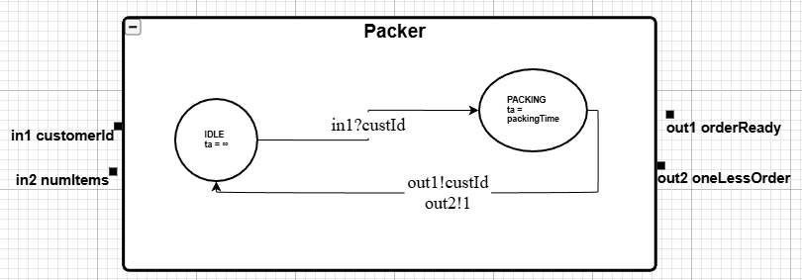
Formal Specification:
$M_{pay} = (X, Y, S, δ_{ext} , δ_{int} , λ, ta)$
$X = \{customerId (int), numItems (int)\}$
$Y = \{orderReady (int), OneLessOrder(int)\}$
$S = \{IDLE, PACKING (packingTime\}$
$ta(IDLE) = inf$
$ta(PACKING) = packingTime$

δext
IF phase == IDLE AND received in1=custId AND in2=items:
packingTime = items * PackTimePerItem
phase = PACKING
ELSE IF phase == PACKING:
(ignore new orders) // simplest version
δint
phase = IDLE
λ
output custId on out1

Cash
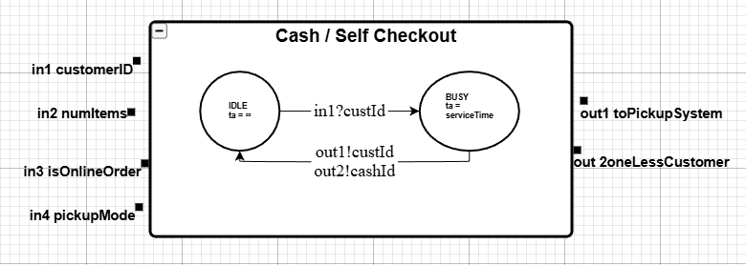
Formal Specification:
$M_{pay} = (X, Y, S, δ_{ext} , δ_{int} , λ, ta)$
$X = \{customerId (int\}, numItems (int), isOnlineOrder (bool), pickupMode (bool)\}$
$Y = \{toPickupSystem(int), oneLessCustomer(int)\}$
$S = \{IDLE, BUSY (serviceTime)\}$
$ta(IDLE) = inf$
$ta(BUSY ) = serviceTime$

δext
IF phase == IDLE AND received in1=custId AND in2=items:
serviceTime = items * TimePerItem
phase = BUSY
ELSE IF phase == BUSY:
(ignore new customers) // simplest version
δint
phase = IDLE
λ
output custId on out1
output myCashId on out2

CurbsideDispatcher
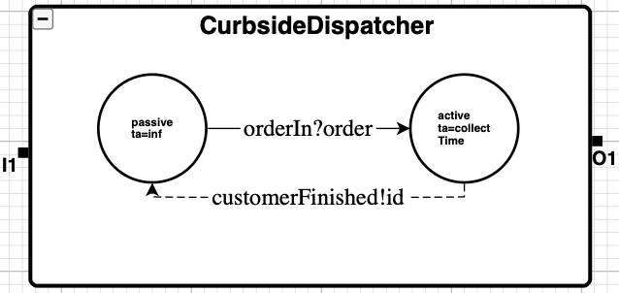
Formal Specification:
$M_{curb} = (X, Y, S, δ_{ext} , δ_{int} , λ, ta)$
$X = \{orderIn ϵ CustomerData\}$
$Y = \{customerFinished ϵ CustomerData\}$
$S = \{IDLE, BUSY (serviceTime)\}$
$ta(IDLE) = inf$
$ta(BUSY ) = serviceTime$

δext:
(orderIn received, passive) → busy
(orderIn received, busy) → busy
δint:
busy → passive
busy → busy
get(jobQueue), $σ$ = Exp(5.0)

λ (output):
busy: emit job to customerFinished

Experimentation and test framework

Generator

Purpose: Validate generator behaviour with control signals (hold and resume) and custom parameters

Expected Behaviour:
- Test 1: Generator start running, produces output, pauses on holdOff, resumes on okGo, and holdOk takes precedence if both arrive
- Test 2: faster arrivals, all online orders, no card payments

Observed Output
- Test 1 shows output at start, silence during the pause window and output resuming afterward
- Test 2 shows multiple outputs within 60s all with isOnlineOrder being true and paymentType being false

=== Test 1: RUNNING start, holdOff/okGo cycle, precedence ===
time,model_id,model_name,port_name,data
0,1,gen,,{phase:running,sigma:0,nextId:0}
0,2,okGoReader,,360
0,3,holdOffReader,,180
0,1,gen,customerOut,{id:0,items:1,online:1,pay:card,travel:328.579,search:18.2474}
0,1,gen,,{phase:running,sigma:8.58341,nextId:1}
8.58341,1,gen,customerOut,{id:1,items:24,online:0,pay:cash,travel:327.008,search:59.3169}
8.58341,1,gen,,{phase:running,sigma:122.976,nextId:2}
131.56,1,gen,customerOut,{id:2,items:22,online:0,pay:cash,travel:288.703,search:11.2322}
131.56,1,gen,,{phase:running,sigma:99.3097,nextId:3}
180,1,gen,,{phase:paused,sigma:inf,nextId:3}
180,3,holdOffReader,out,1
180,3,holdOffReader,,300
360,1,gen,,{phase:running,sigma:10.747,nextId:3}
360,2,okGoReader,out,1
360,2,okGoReader,,120
370.747,1,gen,customerOut,{id:3,items:15,online:1,pay:card,travel:368.18,search:203.489}
370.747,1,gen,,{phase:running,sigma:129.989,nextId:4}
480,1,gen,,{phase:paused,sigma:inf,nextId:4}
480,2,okGoReader,out,1
480,2,okGoReader,,inf
480,3,holdOffReader,out,1
480,3,holdOffReader,,inf
480,1,gen,,{phase:paused,sigma:inf,nextId:4}
480,2,okGoReader,,inf
480,3,holdOffReader,,inf

=== Test 2: Custom params - fast arrivals, all online, no card ===
time,model_id,model_name,port_name,data
0,1,genCustom,,{phase:running,sigma:0,nextId:0}
0,1,genCustom,customerOut,{id:0,items:38,online:1,pay:cash,travel:387.906,search:1.44943}
0,1,genCustom,,{phase:running,sigma:13.4662,nextId:1}
13.4662,1,genCustom,customerOut,{id:1,items:28,online:1,pay:cash,travel:239.863,search:647.951}
13.4662,1,genCustom,,{phase:running,sigma:1.25285,nextId:2}
14.719,1,genCustom,customerOut,{id:2,items:17,online:1,pay:cash,travel:264.924,search:145.838}
14.719,1,genCustom,,{phase:running,sigma:5.86691,nextId:3}
20.586,1,genCustom,customerOut,{id:3,items:38,online:1,pay:cash,travel:370.017,search:31.1027}
20.586,1,genCustom,,{phase:running,sigma:1.30234,nextId:4}
21.8883,1,genCustom,customerOut,{id:4,items:32,online:1,pay:cash,travel:288.342,search:26.6202}
21.8883,1,genCustom,,{phase:running,sigma:1.99658,nextId:5}
23.8849,1,genCustom,customerOut,{id:5,items:23,online:1,pay:cash,travel:295.185,search:102.885}
23.8849,1,genCustom,,{phase:running,sigma:1.94179,nextId:6}
25.8267,1,genCustom,customerOut,{id:6,items:4,online:1,pay:cash,travel:301.889,search:25.1807}
25.8267,1,genCustom,,{phase:running,sigma:7.89824,nextId:7}
33.7249,1,genCustom,customerOut,{id:7,items:21,online:1,pay:cash,travel:286.051,search:235.856}
33.7249,1,genCustom,,{phase:running,sigma:0.619567,nextId:8}
34.3445,1,genCustom,customerOut,{id:8,items:9,online:1,pay:cash,travel:238.288,search:33.2506}
34.3445,1,genCustom,,{phase:running,sigma:21.0811,nextId:9}
55.4256,1,genCustom,customerOut,{id:9,items:20,online:1,pay:cash,travel:340.698,search:87.4072}
55.4256,1,genCustom,,{phase:running,sigma:4.90372,nextId:10}
55.4256,1,genCustom,,{phase:running,sigma:4.90372,nextId:10}

Distributor

Purpose: Confirm routing to correct lanes, queue management, and lane free feedback handling

Expected Behavior:
- Small item customers prefer self checkout when available
- Large item customers prefer staffed cash lanes
- Lane freed messages decrement queue and emit okGo

Observed Output
- Customer 1 with 5 items is routed to self checkout lane 3
- Customer 2 with 20 items goes to a real cash lane 0
- Lane free messages at 0.5 and 1.5 emit out_okGo and reduce queue lengths

=== Distributor Test: Routing + Lane Freed ===
time,model_id,model_name,port_name,data
0,1,distributor,,{phase:idle,hold:0,ok:0,q:[0,0,0,0,0],outbox:0}
0,2,lane_reader,,0.5
0,3,cust_reader,,0
0,1,distributor,,{phase:send,hold:0,ok:0,q:[0,0,0,1,0],outbox:1}
0,3,cust_reader,out,{id:1,items:5,online:0,pay:card,travel:0,search:0}
0,3,cust_reader,,0.1
0,1,distributor,out_self0,{id:1,items:5,online:0,pay:card,travel:0,search:0}
0,1,distributor,out_whichLane,3
0,1,distributor,,{phase:idle,hold:0,ok:0,q:[0,0,0,1,0],outbox:0}
0.1,1,distributor,,{phase:send,hold:0,ok:0,q:[1,0,0,1,0],outbox:1}
0.1,3,cust_reader,out,{id:2,items:20,online:0,pay:cash,travel:0,search:0}
0.1,3,cust_reader,,0.9
0.1,1,distributor,out_cash0,{id:2,items:20,online:0,pay:cash,travel:0,search:0}
0.1,1,distributor,out_whichLane,0
0.1,1,distributor,,{phase:idle,hold:0,ok:0,q:[1,0,0,1,0],outbox:0}
0.5,1,distributor,,{phase:send,hold:0,ok:1,q:[1,0,0,0,0],outbox:0}
0.5,2,lane_reader,out,3
0.5,2,lane_reader,,1
0.5,1,distributor,out_okGo,1
0.5,1,distributor,,{phase:idle,hold:0,ok:0,q:[1,0,0,0,0],outbox:0}
1,1,distributor,,{phase:send,hold:0,ok:0,q:[1,0,0,1,0],outbox:1}
1,3,cust_reader,out,{id:3,items:10,online:1,pay:card,travel:5,search:2}
1,3,cust_reader,,inf
1,1,distributor,out_self0,{id:3,items:10,online:1,pay:card,travel:5,search:2}
1,1,distributor,out_whichLane,3
1,1,distributor,,{phase:idle,hold:0,ok:0,q:[1,0,0,1,0],outbox:0}
1.5,1,distributor,,{phase:send,hold:0,ok:1,q:[0,0,0,1,0],outbox:0}
1.5,2,lane_reader,out,0
1.5,2,lane_reader,,inf
1.5,1,distributor,out_okGo,1
1.5,1,distributor,,{phase:idle,hold:0,ok:0,q:[0,0,0,1,0],outbox:0}
1.5,1,distributor,,{phase:idle,hold:0,ok:0,q:[0,0,0,1,0],outbox:0}
1.5,2,lane_reader,,inf
1.5,3,cust_reader,,inf

Cash

Purpose: Verify a cashier lane processes a single customer, outputs to payment, and emits a lane free signal

Expected Behaviour
- Cash lane receives the customer
- Service time equals items * timePerItem = 12s
- At service completion, outputs out_toPayment and out_free

Observed Output
- At time 0 lane enters busy with a value of 12
- At 12s out_toPayment and out_free are emitted
- Lane returns to IDLE

=== Cash Test: One Customer ===
time,model_id,model_name,port_name,data
0,1,cash0,,{phase:idle,lane:0,sigma:inf}
0,2,cash_reader,,0
0,1,cash0,,{phase:busy,lane:0,sigma:12}
0,2,cash_reader,out,{id:1,items:12,online:0,pay:card,travel:0,search:0}
0,2,cash_reader,,inf
12,1,cash0,out_toPayment,{id:1,items:12,online:0,pay:card,travel:0,search:0}
12,1,cash0,out_free,0
12,1,cash0,,{phase:idle,lane:0,sigma:inf}
12,1,cash0,,{phase:idle,lane:0,sigma:inf}
12,2,cash_reader,,inf

CurbsideDispatcher

Purpose: Confirm pickup timing and queueing of online orders

Expected Behavior:
- First order completes after travel time (5s)
- Second order queues and completes after 2s more

Observed Output
- Order 1 finished at t of 5
- Order 2 finished at t of 7

=== Curbside Test: Pickup Timing ===
time,model_id,model_name,port_name,data
0,1,curbside,,{phase:idle,sigma:inf,queued:0}
0,2,order_reader,,0
0,1,curbside,,{phase:busy,sigma:5,queued:0}
0,2,order_reader,out,{id:1,items:8,online:1,pay:card,travel:5,search:0}
0,2,order_reader,,1
1,1,curbside,,{phase:busy,sigma:4,queued:1}
1,2,order_reader,out,{id:2,items:3,online:1,pay:cash,travel:2,search:0}
1,2,order_reader,,inf
5,1,curbside,finished,{id:1,items:8,online:1,pay:card,travel:5,search:0}
5,1,curbside,,{phase:busy,sigma:2,queued:0}
7,1,curbside,finished,{id:2,items:3,online:1,pay:cash,travel:2,search:0}
7,1,curbside,,{phase:idle,sigma:inf,queued:0}
7,1,curbside,,{phase:idle,sigma:inf,queued:0}
7,2,order_reader,,inf

Packer

Purpose: Verify that only online orders are packed and that packing time is honored

Expected Behavior:
- Online order is accepted and packed
- Walk in order is ignored
- Output occurs at SearchTime for online order (3s)

Observed Output:
- Online Order accepted at t of 0 and packed at t = 3.5
- Walk in order at t 0.5 is ignored

time,model_id,model_name,port_name,data
0,1,packer,,{phase:idle,sigma:inf}
0,2,order_reader,,0
0,1,packer,,{phase:packing,sigma:3}
0,2,order_reader,out,{id:1,items:6,online:1,pay:card,travel:0,search:3}
0,2,order_reader,,0.5
0.5,1,packer,,{phase:packing,sigma:3}
0.5,2,order_reader,out,{id:2,items:4,online:0,pay:cash,travel:0,search:2}
0.5,2,order_reader,,inf
3.5,1,packer,out_packed,{id:1,items:6,online:1,pay:card,travel:0,search:3}
3.5,1,packer,,{phase:idle,sigma:inf}
3.5,1,packer,,{phase:idle,sigma:inf}
3.5,2,order_reader,,inf

Payment

Purpose: Validate queuing and sequential payment processing with variable service times

Expected Behavior:
- First customer starts service immediately
- Second customer queues while busy
- Outputs occur in order of arrival after respective processing times

Observed Output:
- Customer 1 begins service a t = 0 and completes first
- Customer 2 queues and completes after customer 1

=== Payment Test: Two Customers Queue ===
time,model_id,model_name,port_name,data
0,1,payment,,{phase:idle,sigma:inf,queued:0}
0,2,pay_reader,,0
0,1,payment,,{phase:busy,sigma:7.37823,queued:0}
0,2,pay_reader,out,{id:1,items:5,online:0,pay:card,travel:0,search:0}
0,2,pay_reader,,0.1
0.1,1,payment,,{phase:busy,sigma:7.27823,queued:1}
0.1,2,pay_reader,out,{id:2,items:10,online:1,pay:cash,travel:0,search:0}
0.1,2,pay_reader,,inf
7.37823,1,payment,custOut,{id:1,items:5,online:0,pay:card,travel:0,search:0}
7.37823,1,payment,,{phase:busy,sigma:39.7191,queued:0}
47.0974,1,payment,custOut,{id:2,items:10,online:1,pay:cash,travel:0,search:0}
47.0974,1,payment,,{phase:idle,sigma:inf,queued:0}
47.0974,1,payment,,{phase:idle,sigma:inf,queued:0}
47.0974,2,pay_reader,,inf

Traveler

Purpose: Ensure travel takes a fixed number of steps and emits completion at the right time

Expected Behavior:
- Travel begins immediately after input
- One step per second for 10 steps
- custArrived emitted at t of 10

Observed Output
- Traveler transitions to traveling at t of 0
- Emits custArrived at t of 10

=== Traveler Test: One Customer ===
time,model_id,model_name,port_name,data
0,1,traveler,,{phase:idle,steps:0,sigma:inf}
0,2,cust_reader,,0
0,1,traveler,,{phase:travel,steps:10,sigma:1}
0,2,cust_reader,out,{id:1,items:5,online:0,pay:cash,travel:10,search:0}
0,2,cust_reader,,inf
1,1,traveler,,{phase:travel,steps:9,sigma:1}
2,1,traveler,,{phase:travel,steps:8,sigma:1}
3,1,traveler,,{phase:travel,steps:7,sigma:1}
4,1,traveler,,{phase:travel,steps:6,sigma:1}
5,1,traveler,,{phase:travel,steps:5,sigma:1}
6,1,traveler,,{phase:travel,steps:4,sigma:1}
7,1,traveler,,{phase:travel,steps:3,sigma:1}
8,1,traveler,,{phase:travel,steps:2,sigma:1}
9,1,traveler,,{phase:travel,steps:1,sigma:1}
10,1,traveler,custArrived,{id:1,items:5,online:0,pay:cash,travel:10,search:0}
10,1,traveler,,{phase:idle,steps:0,sigma:inf}
10,1,traveler,,{phase:idle,steps:0,sigma:inf}
10,2,cust_reader,,inf

Pickup System Coupled

Purpose: Validate the hierarchical coupling of packer and curbside dispatcher as a single pick system. Tests the internal coordination between packing orders and curbside dispatch

Expected Behaviour
- Online orders arrive at packer input port
- Packer begins packing with a sigma of 3
- Packed orders flow to curbside dispatcher
- Curbside dispatcher immediately processes and outputs finished customers
- Both models remain synchronized via internal coupling

Observed Output:
- Order 1 arrives at packer and packer enters the PACKING with a sigma of 3
- Order 2 arrives at packer input
- Packer completes and outputs order 1 to curb
- Curbside receives order, processes it, emits FINISHED
- Sink receives completed customer; packer returns to IDLE

=== Pickup System Test: Packer + Curbside ===
0,0,packer,,{phase:packing,sigma:3}
0,0,input_reader,out,{id:1,items:6,online:1,pay:card,travel:0,search:3}
0,0,input_reader,,0.5
0.5,0,packer,,{phase:packing,sigma:3}
0.5,0,input_reader,out,{id:2,items:4,online:0,pay:cash,travel:0,search:2}
0.5,0,input_reader,,inf
3.5,0,curbside,,{phase:busy,sigma:0,queued:0}
3.5,0,packer,out_packed,{id:1,items:6,online:1,pay:card,travel:0,search:3}
3.5,0,packer,,{phase:idle,sigma:inf}
3.5,0,sink,,{count:1}
3.5,0,curbside,finished,{id:1,items:6,online:1,pay:card,travel:0,search:3}
3.5,0,curbside,,{phase:idle,sigma:inf,queued:0}

One Customer Integration

Purpose: Validate the core walk in flow from distributor to lane to payment to traveler

Expected Behaviour:
- Route to a lane
- Payment completes
- Then traveler finishes in 10 steps

Observed Output
- Routed to self checkout lane 3
- Payment completes, traveller emits arrival

time,model_id,model_name,port_name,data
0,2,traveler,,{phase:idle,steps:0,sigma:inf}
0,3,curbside,,{phase:idle,sigma:inf,queued:0}
0,4,packer,,{phase:idle,sigma:inf}
0,5,payment,,{phase:idle,sigma:inf,queued:0}
0,6,self1,,{phase:idle,lane:4,sigma:inf}
0,7,self0,,{phase:idle,lane:3,sigma:inf}
0,8,cash2,,{phase:idle,lane:2,sigma:inf}
0,9,cash0,,{phase:idle,lane:0,sigma:inf}
0,10,cash1,,{phase:idle,lane:1,sigma:inf}
0,11,distributor,,{phase:idle,hold:0,ok:0,q:[0,0,0,0,0],outbox:0,online:0}
0,12,input_reader,,0
0,11,distributor,,{phase:send,hold:0,ok:0,q:[0,0,0,1,0],outbox:1,online:0}
0,12,input_reader,out,{id:1,items:5,online:0,pay:cash,travel:10,search:0}
0,12,input_reader,,inf
0,7,self0,,{phase:busy,lane:3,sigma:4}
0,11,distributor,out_self0,{id:1,items:5,online:0,pay:cash,travel:10,search:0}
0,11,distributor,out_whichLane,3
0,11,distributor,,{phase:idle,hold:0,ok:0,q:[0,0,0,1,0],outbox:0,online:0}
4,5,payment,,{phase:busy,sigma:81.25,queued:0}
4,7,self0,out_toPayment,{id:1,items:5,online:0,pay:cash,travel:10,search:0}
4,7,self0,out_free,3
4,7,self0,,{phase:idle,lane:3,sigma:inf}
4,11,distributor,,{phase:send,hold:0,ok:1,q:[0,0,0,0,0],outbox:0,online:0}
4,11,distributor,out_okGo,1
4,11,distributor,,{phase:idle,hold:0,ok:0,q:[0,0,0,0,0],outbox:0,online:0}
85.25,2,traveler,,{phase:travel,steps:10,sigma:1}
85.25,5,payment,custOut,{id:1,items:5,online:0,pay:cash,travel:10,search:0}
85.25,5,payment,,{phase:idle,sigma:inf,queued:0}
86.25,2,traveler,,{phase:travel,steps:9,sigma:1}
87.25,2,traveler,,{phase:travel,steps:8,sigma:1}
88.25,2,traveler,,{phase:travel,steps:7,sigma:1}
89.25,2,traveler,,{phase:travel,steps:6,sigma:1}
90.25,2,traveler,,{phase:travel,steps:5,sigma:1}
91.25,2,traveler,,{phase:travel,steps:4,sigma:1}
92.25,2,traveler,,{phase:travel,steps:3,sigma:1}
93.25,2,traveler,,{phase:travel,steps:2,sigma:1}
94.25,2,traveler,,{phase:travel,steps:1,sigma:1}
95.25,2,traveler,custArrived,{id:1,items:5,online:0,pay:cash,travel:10,search:0}
95.25,2,traveler,,{phase:idle,steps:0,sigma:inf}
95.25,2,traveler,,{phase:idle,steps:0,sigma:inf}
95.25,3,curbside,,{phase:idle,sigma:inf,queued:0}
95.25,4,packer,,{phase:idle,sigma:inf}
95.25,5,payment,,{phase:idle,sigma:inf,queued:0}
95.25,6,self1,,{phase:idle,lane:4,sigma:inf}
95.25,7,self0,,{phase:idle,lane:3,sigma:inf}
95.25,8,cash2,,{phase:idle,lane:2,sigma:inf}
95.25,9,cash0,,{phase:idle,lane:0,sigma:inf}
95.25,10,cash1,,{phase:idle,lane:1,sigma:inf}
95.25,11,distributor,,{phase:idle,hold:0,ok:0,q:[0,0,0,0,0],outbox:0,online:0}
95.25,12,input_reader,,inf
Done.

Full System Tests

Purpose: End to end integration test using file driven inputs instead of random generator

Expected Behaviour:
- Walk ins go through checkout and traveler
- Online orders bypass checkout to packing curbside

Observed Output:
- Both paths appear in the log with consistent ordering and timing

=== Full System Deterministic Test ===
time,model_id,model_name,port_name,data
0,2,traveler,,{phase:idle,steps:0,sigma:inf}
0,3,curbside,,{phase:idle,sigma:inf,queued:0}
0,4,packer,,{phase:idle,sigma:inf}
0,5,payment,,{phase:idle,sigma:inf,queued:0}
0,6,self1,,{phase:idle,lane:4,sigma:inf}
0,7,self0,,{phase:idle,lane:3,sigma:inf}
0,8,cash2,,{phase:idle,lane:2,sigma:inf}
0,9,cash0,,{phase:idle,lane:0,sigma:inf}
0,10,cash1,,{phase:idle,lane:1,sigma:inf}
0,11,distributor,,{phase:idle,hold:0,ok:0,q:[0,0,0,0,0],outbox:0,online:0}
0,12,cust_reader,,0
0,11,distributor,,{phase:send,hold:0,ok:0,q:[0,0,0,1,0],outbox:1,online:0}
0,12,cust_reader,out,{id:1,items:5,online:0,pay:card,travel:10,search:0}
0,12,cust_reader,,1
0,7,self0,,{phase:busy,lane:3,sigma:4}
0,11,distributor,out_self0,{id:1,items:5,online:0,pay:card,travel:10,search:0}
0,11,distributor,out_whichLane,3
0,11,distributor,,{phase:idle,hold:0,ok:0,q:[0,0,0,1,0],outbox:0,online:0}
1,11,distributor,,{phase:send,hold:0,ok:0,q:[1,0,0,1,0],outbox:1,online:0}
1,12,cust_reader,out,{id:2,items:18,online:0,pay:cash,travel:15,search:0}
1,12,cust_reader,,1
1,9,cash0,,{phase:busy,lane:0,sigma:18}
1,11,distributor,out_cash0,{id:2,items:18,online:0,pay:cash,travel:15,search:0}
1,11,distributor,out_whichLane,0
1,11,distributor,,{phase:idle,hold:0,ok:0,q:[1,0,0,1,0],outbox:0,online:0}
2,11,distributor,,{phase:send,hold:0,ok:0,q:[1,0,0,1,0],outbox:0,online:1}
2,12,cust_reader,out,{id:3,items:7,online:1,pay:card,travel:20,search:4}
2,12,cust_reader,,4
2,4,packer,,{phase:packing,sigma:4}
2,11,distributor,out_online,{id:3,items:7,online:1,pay:card,travel:20,search:4}
2,11,distributor,,{phase:idle,hold:0,ok:0,q:[1,0,0,1,0],outbox:0,online:0}
4,5,payment,,{phase:busy,sigma:5.07558,queued:0}
4,7,self0,out_toPayment,{id:1,items:5,online:0,pay:card,travel:10,search:0}
4,7,self0,out_free,3
4,7,self0,,{phase:idle,lane:3,sigma:inf}
4,11,distributor,,{phase:send,hold:0,ok:1,q:[1,0,0,0,0],outbox:0,online:0}
4,11,distributor,out_okGo,1
4,11,distributor,,{phase:idle,hold:0,ok:0,q:[1,0,0,0,0],outbox:0,online:0}
6,3,curbside,,{phase:busy,sigma:20,queued:0}
6,4,packer,out_packed,{id:3,items:7,online:1,pay:card,travel:20,search:4}
6,4,packer,,{phase:idle,sigma:inf}
6,11,distributor,,{phase:send,hold:0,ok:0,q:[1,0,0,1,0],outbox:1,online:0}
6,12,cust_reader,out,{id:4,items:12,online:0,pay:card,travel:8,search:0}
6,12,cust_reader,,2
6,7,self0,,{phase:busy,lane:3,sigma:9.6}
6,11,distributor,out_self0,{id:4,items:12,online:0,pay:card,travel:8,search:0}
6,11,distributor,out_whichLane,3
6,11,distributor,,{phase:idle,hold:0,ok:0,q:[1,0,0,1,0],outbox:0,online:0}
8,11,distributor,,{phase:send,hold:0,ok:0,q:[1,0,0,1,0],outbox:0,online:1}
8,12,cust_reader,out,{id:5,items:6,online:1,pay:cash,travel:12,search:3}
8,12,cust_reader,,inf
8,4,packer,,{phase:packing,sigma:3}
8,11,distributor,out_online,{id:5,items:6,online:1,pay:cash,travel:12,search:3}
8,11,distributor,,{phase:idle,hold:0,ok:0,q:[1,0,0,1,0],outbox:0,online:0}
9.07558,2,traveler,,{phase:travel,steps:10,sigma:1}
9.07558,5,payment,custOut,{id:1,items:5,online:0,pay:card,travel:10,search:0}
9.07558,5,payment,,{phase:idle,sigma:inf,queued:0}
10.0756,2,traveler,,{phase:travel,steps:9,sigma:1}
11,3,curbside,,{phase:busy,sigma:15,queued:1}
11,4,packer,out_packed,{id:5,items:6,online:1,pay:cash,travel:12,search:3}
11,4,packer,,{phase:idle,sigma:inf}
11.0756,2,traveler,,{phase:travel,steps:8,sigma:1}
12.0756,2,traveler,,{phase:travel,steps:7,sigma:1}
13.0756,2,traveler,,{phase:travel,steps:6,sigma:1}
14.0756,2,traveler,,{phase:travel,steps:5,sigma:1}
15.0756,2,traveler,,{phase:travel,steps:4,sigma:1}
15.6,5,payment,,{phase:busy,sigma:12.3178,queued:0}
15.6,7,self0,out_toPayment,{id:4,items:12,online:0,pay:card,travel:8,search:0}
15.6,7,self0,out_free,3
15.6,7,self0,,{phase:idle,lane:3,sigma:inf}
15.6,11,distributor,,{phase:send,hold:0,ok:1,q:[1,0,0,0,0],outbox:0,online:0}
15.6,11,distributor,out_okGo,1
15.6,11,distributor,,{phase:idle,hold:0,ok:0,q:[1,0,0,0,0],outbox:0,online:0}
16.0756,2,traveler,,{phase:travel,steps:3,sigma:1}
17.0756,2,traveler,,{phase:travel,steps:2,sigma:1}
18.0756,2,traveler,,{phase:travel,steps:1,sigma:1}
19,5,payment,,{phase:busy,sigma:8.91775,queued:1}
19,9,cash0,out_toPayment,{id:2,items:18,online:0,pay:cash,travel:15,search:0}
19,9,cash0,out_free,0
19,9,cash0,,{phase:idle,lane:0,sigma:inf}
19,11,distributor,,{phase:send,hold:0,ok:1,q:[0,0,0,0,0],outbox:0,online:0}
19,11,distributor,out_okGo,1
19,11,distributor,,{phase:idle,hold:0,ok:0,q:[0,0,0,0,0],outbox:0,online:0}
19.0756,2,traveler,custArrived,{id:1,items:5,online:0,pay:card,travel:10,search:0}
19.0756,2,traveler,,{phase:idle,steps:0,sigma:inf}
26,3,curbside,finished,{id:3,items:7,online:1,pay:card,travel:20,search:4}
26,3,curbside,,{phase:busy,sigma:12,queued:0}
27.9178,2,traveler,,{phase:travel,steps:10,sigma:1}
27.9178,5,payment,custOut,{id:4,items:12,online:0,pay:card,travel:8,search:0}
27.9178,5,payment,,{phase:busy,sigma:48.3114,queued:0}
28.9178,2,traveler,,{phase:travel,steps:9,sigma:1}
29.9178,2,traveler,,{phase:travel,steps:8,sigma:1}
30.9178,2,traveler,,{phase:travel,steps:7,sigma:1}
31.9178,2,traveler,,{phase:travel,steps:6,sigma:1}
32.9178,2,traveler,,{phase:travel,steps:5,sigma:1}
33.9178,2,traveler,,{phase:travel,steps:4,sigma:1}
34.9178,2,traveler,,{phase:travel,steps:3,sigma:1}
35.9178,2,traveler,,{phase:travel,steps:2,sigma:1}
36.9178,2,traveler,,{phase:travel,steps:1,sigma:1}
37.9178,2,traveler,custArrived,{id:4,items:12,online:0,pay:card,travel:8,search:0}
37.9178,2,traveler,,{phase:idle,steps:0,sigma:inf}
38,3,curbside,finished,{id:5,items:6,online:1,pay:cash,travel:12,search:3}
38,3,curbside,,{phase:idle,sigma:inf,queued:0}
76.2292,2,traveler,,{phase:travel,steps:10,sigma:1}
76.2292,5,payment,custOut,{id:2,items:18,online:0,pay:cash,travel:15,search:0}
76.2292,5,payment,,{phase:idle,sigma:inf,queued:0}
77.2292,2,traveler,,{phase:travel,steps:9,sigma:1}
78.2292,2,traveler,,{phase:travel,steps:8,sigma:1}
79.2292,2,traveler,,{phase:travel,steps:7,sigma:1}
80.2292,2,traveler,,{phase:travel,steps:6,sigma:1}
81.2292,2,traveler,,{phase:travel,steps:5,sigma:1}
82.2292,2,traveler,,{phase:travel,steps:4,sigma:1}
83.2292,2,traveler,,{phase:travel,steps:3,sigma:1}
84.2292,2,traveler,,{phase:travel,steps:2,sigma:1}
85.2292,2,traveler,,{phase:travel,steps:1,sigma:1}
86.2292,2,traveler,custArrived,{id:2,items:18,online:0,pay:cash,travel:15,search:0}
86.2292,2,traveler,,{phase:idle,steps:0,sigma:inf}
86.2292,2,traveler,,{phase:idle,steps:0,sigma:inf}
86.2292,3,curbside,,{phase:idle,sigma:inf,queued:0}
86.2292,4,packer,,{phase:idle,sigma:inf}
86.2292,5,payment,,{phase:idle,sigma:inf,queued:0}
86.2292,6,self1,,{phase:idle,lane:4,sigma:inf}
86.2292,7,self0,,{phase:idle,lane:3,sigma:inf}
86.2292,8,cash2,,{phase:idle,lane:2,sigma:inf}
86.2292,9,cash0,,{phase:idle,lane:0,sigma:inf}
86.2292,10,cash1,,{phase:idle,lane:1,sigma:inf}
86.2292,11,distributor,,{phase:idle,hold:0,ok:0,q:[0,0,0,0,0],outbox:0,online:0}
86.2292,12,cust_reader,,inf

Simulation experiments and test frameworks

Example Full Run

Evidence in the output of functioning system:
- Online Orders skip checkout
  - At time 0 customer id 0 is online and the distributor emits out_online instead of a checkout lane
- Walk in customer go through lanes and payment
  - At t 177.078 customer id 2 is online 0 and is routed to cash lane 0
  - The cash lane enters busy with a time of 27 times
- Payment Type affects timing
  - Both card and cash payments are in the log, id 2 is card, id 5 is cash, The payment processors sigma varies based on the payment time

Output (Simulation time 300s)
time,model_id,model_name,port_name,data
0,1,sink_online,,{count:0}
0,2,traveler,,{phase:idle,steps:0,sigma:inf}
0,3,curbside,,{phase:idle,sigma:inf,queued:0}
0,4,packer,,{phase:idle,sigma:inf}
0,5,payment,,{phase:idle,sigma:inf,queued:0}
0,6,self1,,{phase:idle,lane:4,sigma:inf}
0,7,self0,,{phase:idle,lane:3,sigma:inf}
0,8,sink_walkin,,{count:0}
0,9,cash2,,{phase:idle,lane:2,sigma:inf}
0,10,cash0,,{phase:idle,lane:0,sigma:inf}
0,11,cash1,,{phase:idle,lane:1,sigma:inf}
0,12,distributor,,{phase:idle,hold:0,ok:0,q:[0,0,0,0,0],outbox:0,online:0}
0,13,generator,,{phase:running,sigma:0,nextId:0}
0,12,distributor,,{phase:send,hold:0,ok:0,q:[0,0,0,0,0],outbox:0,online:1}
0,13,generator,customerOut,{id:0,items:21,online:1,pay:card,travel:352.986,search:115.729}
0,13,generator,,{phase:running,sigma:75.7806,nextId:1}
0,4,packer,,{phase:packing,sigma:115.729}
0,12,distributor,out_online,{id:0,items:21,online:1,pay:card,travel:352.986,search:115.729}
0,12,distributor,,{phase:idle,hold:0,ok:0,q:[0,0,0,0,0],outbox:0,online:0}
75.7806,12,distributor,,{phase:send,hold:0,ok:0,q:[0,0,0,0,0],outbox:0,online:1}
75.7806,13,generator,customerOut,{id:1,items:17,online:1,pay:cash,travel:365.532,search:237.591}
75.7806,13,generator,,{phase:running,sigma:101.297,nextId:2}
75.7806,4,packer,,{phase:packing,sigma:115.729}
75.7806,12,distributor,out_online,{id:1,items:17,online:1,pay:cash,travel:365.532,search:237.591}
75.7806,12,distributor,,{phase:idle,hold:0,ok:0,q:[0,0,0,0,0],outbox:0,online:0}
177.078,12,distributor,,{phase:send,hold:0,ok:0,q:[1,0,0,0,0],outbox:1,online:0}
177.078,13,generator,customerOut,{id:2,items:27,online:0,pay:card,travel:398.905,search:5.72546}
177.078,13,generator,,{phase:running,sigma:4.54825,nextId:3}
177.078,10,cash0,,{phase:busy,lane:0,sigma:27}
177.078,12,distributor,out_cash0,{id:2,items:27,online:0,pay:card,travel:398.905,search:5.72546}
177.078,12,distributor,out_whichLane,0
177.078,12,distributor,,{phase:idle,hold:0,ok:0,q:[1,0,0,0,0],outbox:0,online:0}
181.626,12,distributor,,{phase:send,hold:0,ok:0,q:[1,1,0,0,0],outbox:1,online:0}
181.626,13,generator,customerOut,{id:3,items:32,online:0,pay:card,travel:242.458,search:49.2525}
181.626,13,generator,,{phase:running,sigma:85.7647,nextId:4}
181.626,11,cash1,,{phase:busy,lane:1,sigma:32}
181.626,12,distributor,out_cash1,{id:3,items:32,online:0,pay:card,travel:242.458,search:49.2525}
181.626,12,distributor,out_whichLane,1
181.626,12,distributor,,{phase:idle,hold:0,ok:0,q:[1,1,0,0,0],outbox:0,online:0}
191.51,3,curbside,,{phase:busy,sigma:352.986,queued:0}
191.51,4,packer,out_packed,{id:0,items:21,online:1,pay:card,travel:352.986,search:115.729}
191.51,4,packer,,{phase:idle,sigma:inf}
204.078,5,payment,,{phase:busy,sigma:7.88511,queued:0}
204.078,10,cash0,out_toPayment,{id:2,items:27,online:0,pay:card,travel:398.905,search:5.72546}
204.078,10,cash0,out_free,0
204.078,10,cash0,,{phase:idle,lane:0,sigma:inf}
204.078,12,distributor,,{phase:send,hold:0,ok:1,q:[0,1,0,0,0],outbox:0,online:0}
204.078,12,distributor,out_okGo,1
204.078,12,distributor,,{phase:idle,hold:0,ok:0,q:[0,1,0,0,0],outbox:0,online:0}
204.078,13,generator,,{phase:running,sigma:63.3129,nextId:4}
211.963,2,traveler,,{phase:travel,steps:10,sigma:1}
211.963,5,payment,custOut,{id:2,items:27,online:0,pay:card,travel:398.905,search:5.72546}
211.963,5,payment,,{phase:idle,sigma:inf,queued:0}
212.963,2,traveler,,{phase:travel,steps:9,sigma:1}
213.626,5,payment,,{phase:busy,sigma:12.6773,queued:0}
213.626,11,cash1,out_toPayment,{id:3,items:32,online:0,pay:card,travel:242.458,search:49.2525}
213.626,11,cash1,out_free,1
213.626,11,cash1,,{phase:idle,lane:1,sigma:inf}
213.626,12,distributor,,{phase:send,hold:0,ok:1,q:[0,0,0,0,0],outbox:0,online:0}
213.626,12,distributor,out_okGo,1
213.626,12,distributor,,{phase:idle,hold:0,ok:0,q:[0,0,0,0,0],outbox:0,online:0}
213.626,13,generator,,{phase:running,sigma:53.7647,nextId:4}
213.963,2,traveler,,{phase:travel,steps:8,sigma:1}
214.963,2,traveler,,{phase:travel,steps:7,sigma:1}
215.963,2,traveler,,{phase:travel,steps:6,sigma:1}
216.963,2,traveler,,{phase:travel,steps:5,sigma:1}
217.963,2,traveler,,{phase:travel,steps:4,sigma:1}
218.963,2,traveler,,{phase:travel,steps:3,sigma:1}
219.963,2,traveler,,{phase:travel,steps:2,sigma:1}
220.963,2,traveler,,{phase:travel,steps:1,sigma:1}
221.963,2,traveler,custArrived,{id:2,items:27,online:0,pay:card,travel:398.905,search:5.72546}
221.963,2,traveler,,{phase:idle,steps:0,sigma:inf}
221.963,8,sink_walkin,,{count:1}
226.304,2,traveler,,{phase:travel,steps:10,sigma:1}
226.304,5,payment,custOut,{id:3,items:32,online:0,pay:card,travel:242.458,search:49.2525}
226.304,5,payment,,{phase:idle,sigma:inf,queued:0}
227.304,2,traveler,,{phase:travel,steps:9,sigma:1}
228.304,2,traveler,,{phase:travel,steps:8,sigma:1}
229.304,2,traveler,,{phase:travel,steps:7,sigma:1}
230.304,2,traveler,,{phase:travel,steps:6,sigma:1}
231.304,2,traveler,,{phase:travel,steps:5,sigma:1}
232.304,2,traveler,,{phase:travel,steps:4,sigma:1}
233.304,2,traveler,,{phase:travel,steps:3,sigma:1}
234.304,2,traveler,,{phase:travel,steps:2,sigma:1}
235.304,2,traveler,,{phase:travel,steps:1,sigma:1}
236.304,2,traveler,custArrived,{id:3,items:32,online:0,pay:card,travel:242.458,search:49.2525}
236.304,2,traveler,,{phase:idle,steps:0,sigma:inf}
236.304,8,sink_walkin,,{count:2}
267.391,12,distributor,,{phase:send,hold:0,ok:0,q:[0,0,0,1,0],outbox:1,online:0}
267.391,13,generator,customerOut,{id:4,items:8,online:0,pay:card,travel:280.959,search:13.8991}
267.391,13,generator,,{phase:running,sigma:4.40342,nextId:5}
267.391,7,self0,,{phase:busy,lane:3,sigma:6.4}
267.391,12,distributor,out_self0,{id:4,items:8,online:0,pay:card,travel:280.959,search:13.8991}
267.391,12,distributor,out_whichLane,3
267.391,12,distributor,,{phase:idle,hold:0,ok:0,q:[0,0,0,1,0],outbox:0,online:0}
271.794,12,distributor,,{phase:send,hold:0,ok:0,q:[1,0,0,1,0],outbox:1,online:0}
271.794,13,generator,customerOut,{id:5,items:40,online:0,pay:cash,travel:360.417,search:272.841}
271.794,13,generator,,{phase:running,sigma:25.0064,nextId:6}
271.794,10,cash0,,{phase:busy,lane:0,sigma:40}
271.794,12,distributor,out_cash0,{id:5,items:40,online:0,pay:cash,travel:360.417,search:272.841}
271.794,12,distributor,out_whichLane,0
271.794,12,distributor,,{phase:idle,hold:0,ok:0,q:[1,0,0,1,0],outbox:0,online:0}
273.791,5,payment,,{phase:busy,sigma:11.6606,queued:0}
273.791,7,self0,out_toPayment,{id:4,items:8,online:0,pay:card,travel:280.959,search:13.8991}
273.791,7,self0,out_free,3
273.791,7,self0,,{phase:idle,lane:3,sigma:inf}
273.791,12,distributor,,{phase:send,hold:0,ok:1,q:[1,0,0,0,0],outbox:0,online:0}
273.791,12,distributor,out_okGo,1
273.791,12,distributor,,{phase:idle,hold:0,ok:0,q:[1,0,0,0,0],outbox:0,online:0}
273.791,13,generator,,{phase:running,sigma:23.0098,nextId:6}
285.452,2,traveler,,{phase:travel,steps:10,sigma:1}
285.452,5,payment,custOut,{id:4,items:8,online:0,pay:card,travel:280.959,search:13.8991}
285.452,5,payment,,{phase:idle,sigma:inf,queued:0}
286.452,2,traveler,,{phase:travel,steps:9,sigma:1}
287.452,2,traveler,,{phase:travel,steps:8,sigma:1}
288.452,2,traveler,,{phase:travel,steps:7,sigma:1}
289.452,2,traveler,,{phase:travel,steps:6,sigma:1}
290.452,2,traveler,,{phase:travel,steps:5,sigma:1}
291.452,2,traveler,,{phase:travel,steps:4,sigma:1}
292.452,2,traveler,,{phase:travel,steps:3,sigma:1}
293.452,2,traveler,,{phase:travel,steps:2,sigma:1}
294.452,2,traveler,,{phase:travel,steps:1,sigma:1}
295.452,2,traveler,custArrived,{id:4,items:8,online:0,pay:card,travel:280.959,search:13.8991}
295.452,2,traveler,,{phase:idle,steps:0,sigma:inf}
295.452,8,sink_walkin,,{count:3}
296.801,12,distributor,,{phase:send,hold:0,ok:0,q:[1,0,0,1,0],outbox:1,online:0}
296.801,13,generator,customerOut,{id:6,items:4,online:0,pay:card,travel:301.865,search:26.5743}
296.801,13,generator,,{phase:running,sigma:5.97159,nextId:7}
296.801,7,self0,,{phase:busy,lane:3,sigma:3.2}
296.801,12,distributor,out_self0,{id:6,items:4,online:0,pay:card,travel:301.865,search:26.5743}
296.801,12,distributor,out_whichLane,3
296.801,12,distributor,,{phase:idle,hold:0,ok:0,q:[1,0,0,1,0],outbox:0,online:0}
296.801,1,sink_online,,{count:0}
296.801,2,traveler,,{phase:idle,steps:0,sigma:inf}
296.801,3,curbside,,{phase:busy,sigma:352.986,queued:0}
296.801,4,packer,,{phase:idle,sigma:inf}
296.801,5,payment,,{phase:idle,sigma:inf,queued:0}
296.801,6,self1,,{phase:idle,lane:4,sigma:inf}
296.801,7,self0,,{phase:busy,lane:3,sigma:3.2}
296.801,8,sink_walkin,,{count:3}
296.801,9,cash2,,{phase:idle,lane:2,sigma:inf}
296.801,10,cash0,,{phase:busy,lane:0,sigma:40}
296.801,11,cash1,,{phase:idle,lane:1,sigma:inf}
296.801,12,distributor,,{phase:idle,hold:0,ok:0,q:[1,0,0,1,0],outbox:0,online:0}
296.801,13,generator,,{phase:running,sigma:5.97159,nextId:7}
Grocery store simulation completed.

Implementation notes and how to run

Repository Structure:
The source code, test files, input data, logs and this report are hosted on Github at: https://github.com/jtkandrews/GroceryStoreDEVS
The repository follows the same structure as the alternatingbitprotocol reference example. Each atomic and coupled model has its own header file. Test drivers, input files, and log outputs are organized into separate directories.

Requirements
- C++17 compatible compiler (g++)
- A local installation of the Cadmium v2 simulation library

Building and Running

Build the main simulation:
make

Run the main simulation:
make run

Build the unit/integration tests:
make tests

Run the tests:
make run-tests

Input Files
Test input files are located in the input_data/ directory.

Simulation Logs
Saved log outputs are written to the simulation_results/ directory after each run:
- main_run.log - output from the full top-model simulation
- tests_run.log - output from the atomic and coupled model unit tests

